Name: Nawal Fatima
Roll no: 94
Section: BSAI-3B
Lab task 3

Introduction:
Is lab mein hum ne uninformed search algorithms (BFS, DFS, DLS, IDDFS aur UCS) ko ek chhote emergency-exit graph par apply kiya. Graph mein A start hai aur G exit hai. Successor-list ka order hi tie-breaking order hai, aur depth edges se count hoti hai (A ka depth 0 hai). Saare trace code se actual run karke liye gaye hain, expected answer ke hisaab se badle nahi.

State-Space Formulation
Element | Description
Initial state | A
Goal test | node == G
Actions / successors | A:[B,C], B:[D,E], C:[F], E:[G], baaki khali
Path cost | Original graph mein har edge ka cost 1; weighted version mein Task 3 ki table

Task 1: BFS aur DFS Manual Trace
Convention: har wo node likhi gayi hai jo queue/stack se nikal kar process hui (goal samet). Duplicate skip kiye gaye.
BFS trace (queue front se nikalti hai):
Step | Processed | Path | Queue (process ke baad) | Note
1 | A | A | B, C | A ke successors add
2 | B | A-B | C, D, E
3 | C | A-C | D, E, F
4 | D | A-B-D | E, F | D ke koi successor nahi
5 | E | A-B-E | F, G
6 | F | A-C-F | G
7 | G | A-B-E-G | (khali) | Goal
BFS visit order: A, B, C, D, E, F, G. Final path: A -> B -> E -> G (3 edges).
DFS trace (stack top se nikalti hai, successors reversed push hote hain):
Step | Processed | Path | Stack (top aakhir mein) | Note
1 | A | A | C, B | Reversed push se B top par
2 | B | A-B | C, E, D | D top par
3 | D | A-B-D | C, E | D dead end
4 | E | A-B-E | C, G
5 | G | A-B-E-G | - | Goal
DFS visit order: A, B, D, E, G. Final path: A -> B -> E -> G. Dono ka path same hai lekin visit order alag hai: BFS ne 7 nodes process kiye aur DFS ne 5. Reversed insertion isliye kiya ke stack last-in-first-out hai, to pehla listed neighbour sabse pehle nikle.
Code (lab3_bfs_dfs.py):
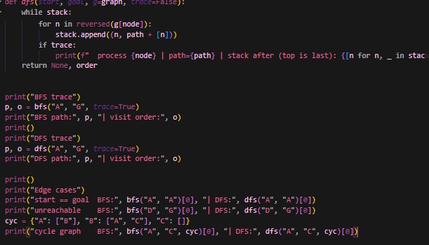

Output:
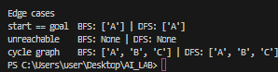

Task 2: DLS aur IDDFS
Root depth 0 hai, path-local cycle check lagaya gaya hai aur koi global visited set nahi rakha. Status teen tarah ka hai: FOUND, CUTOFF (aage ek unexplored continuation maujood hai) aur FAILURE (branch khatam ho gayi).
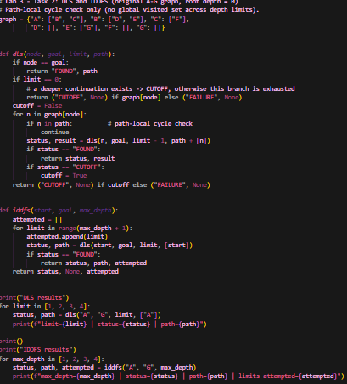

Output:
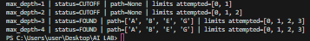

DLS limit | Status | Path | Wajah
1 | CUTOFF | - | Limit 1 par sirf B aur C tak pahunche, G depth 3 par hai
2 | CUTOFF | - | Depth 2 par E tak pahunche lekin G ek aur edge door hai
3 | FOUND | A-B-E-G | G ka depth exactly 3 hai
4 | FOUND | A-B-E-G | Limit kaafi hai

IDDFS max depth | Status | Path | Limits attempted
1 | CUTOFF | - | 0, 1
2 | CUTOFF | - | 0, 1, 2
3 | FOUND | A-B-E-G | 0, 1, 2, 3
4 | FOUND | A-B-E-G | 0, 1, 2, 3 (limit 3 par mil gaya, 4 ki zaroorat nahi padi)
Repeated work: IDDFS har naye limit par shuru se search dohrata hai, jaise A aur B baar baar expand hote hain. Limits 3 se neeche kamyab isliye nahi hote ke G ka depth 3 hai, to 1 aur 2 par sirf bounded-search ka result CUTOFF aata hai, ye proof nahi ke G unreachable hai.

Task 3: Weighted Graph aur UCS
Weighted extension (manual Section 3.7): asli corridors rakhe gaye aur C -> G ka alternative corridor explicitly add kiya gaya. Saare weights nonnegative hain. Manual ke reference mein diye gaye weights is text mein nahi the, is liye weights is lab ke liye aise chune gaye ke manual ka bataya hua natija aaye (BFS: A-C-G cost 12, UCS: A-B-E-G cost 3). Ye weights lab assumptions hain, real data nahi.
Edge | Weight | Note
A -> B | 1 | Original
A -> C | 5 | Original
B -> D | 2 | Original
B -> E | 1 | Original
C -> F | 2 | Original
C -> G | 7 | Naya added corridor (extension)
E -> G | 1 | Original

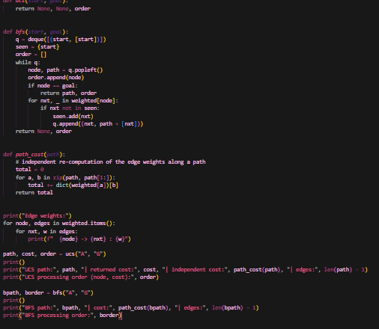

Output:
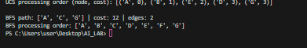

Algorithm | Path | Edges | Cost | Processing order
UCS | A-B-E-G | 3 | 3 | A(0), B(1), E(2), D(3), G(3)
BFS | A-C-G | 2 | 12 | A, B, C, D, E, F, G
Independent cost check: UCS path = 1 (A-B) + 1 (B-E) + 1 (E-G) = 3. BFS path = 5 (A-C) + 7 (C-G) = 12.
Kam hops wala route zyada costly kyun? BFS sirf edges ginta hai, weights nahi dekhta, is liye 2-edge route A-C-G pasand karta hai jo cost mein 12 hai. UCS accumulated cost ke hisaab se expand karta hai, is liye 3-edge lekin sasta route (cost 3) chunta hai. UCS ke liye nonnegative edges zaroori hain.

Edge Cases / Testing
Test | Result | Observation
Start == Goal (A to A) | BFS aur DFS: [A] | Foran goal, koi expansion nahi
Unreachable goal (D to G) | BFS aur DFS: None | D ke koi successor nahi, search khatam
Cycle wala graph (A<->B, B->C) | BFS aur DFS: A-B-C | Seen set cycle mein loop nahi hone deta

Edge Case / Failure Analysis
Input: DLS, limit 2, start A, goal G.
Observed behavior: status CUTOFF, koi path nahi.
Likely cause: G ka depth 3 hai, aur limit 2 par E (depth 2) tak pahunch kar search ruk jati hai, jabki E ka successor G maujood hai.
Proposed improvement: CUTOFF ko FAILURE na samjho. Limit badhao ya IDDFS use karo, jo limit 3 par apne aap FOUND de deta hai.

Complexity Comparison
Strategy | Complete? | Optimal? | Resource behaviour
BFS | Haan (finite branching) | Haan, equal step cost par | Broad levels par zyada memory
DFS | Hamesha nahi | Nahi | Kam memory, gehra ja sakta hai
DLS | Limit kaafi ho to | Nahi | Depth bounded
IDDFS | Haan | Haan, equal step cost par | Shallow work dohrata hai
UCS | Haan, positive costs par | Haan | Priority queue, path cost ke hisaab se

Limitations
Graph chhota aur synthetic hai, aur weights lab assumptions hain, is liye time aur memory ka comparison sirf is graph tak mehdood hai. UCS negative costs ke liye theek nahi. DFS ya DLS ka path optimal hone ki guarantee nahi deta.

Reflection
What did you learn today? BFS, DFS aur UCS alag order mein nodes expand karte hain, aur sirf path dekh kar pata nahi chalta ke search kaise hui.
How will you apply this? Real system mein cost wale problems par UCS aur memory ki kami wale problems par IDDFS use karungi.
What failed or surprised you? Kam hops wala route (A-C-G) cost mein zyada nikla.
What would you do differently? Code chalane se pehle trace khud predict karungi.

Responsible Practice
Saare traces actual code run se liye gaye hain aur expected answer ke hisaab se badle nahi. Weights synthetic hain aur ye wazahat report mein likh di gayi hai.

